

Ministry of Energy

*The monthly statistics Report*



**August/September 2020**

Section 1

Water Industry

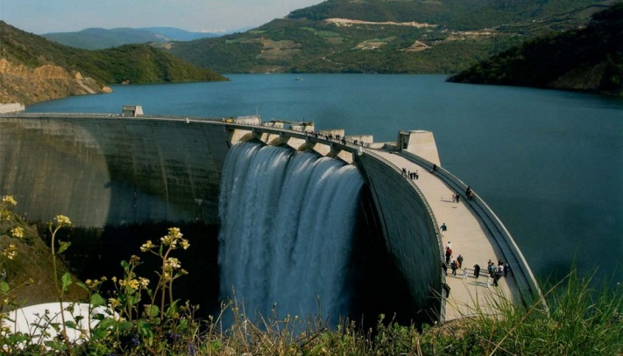

1-1-Rainfall height

Table 1-1-Rainfall (atmospheric rainfall situation*)

From 22 of September 2019 to 21 August 2020) (part of Iranian Water Year 1398-1399) **

|  |  |  |  |  |  |
| --- | --- | --- | --- | --- | --- |
| The percentage of difference | | Rainfall Height (mm) | | | Main water basin |
| Long term average | Last water Year | Long term average | Last water Year | This water year |
| 14 | -14 | 5/431 | 8/570 | 8/491 | Caspian Sea |
| 23 | -16 | 1/366 | 7/535 | 7/449 | Persian Gulf and Oman Sea |
| 6 | -26 | 8/344 | 494 | 1/366 | Urumia Lake |
| 41 | 9 | 7/164 | 214 | 5/232 | Central plateau |
| 38 | 24 | 8/170 | 3/120 | 6/148 | The eastern border basin |
| 31 | -6 | 1/222 | 2/130 | 7/291 | Serakhs |
| 27 | -7 | 8/249 | 1/342 | 7/317 | whole country |

**\*** The volume of precipitation from 11 October 2019 till 20 May 2020 in the current water year is 501.98 billion cubic meters.

**Water Year, also called hydrological year: It is a term commonly used in [hydrology](https://en.wikipedia.org/wiki/Hydrology) to describe a time period of 12 months for which [precipitation](https://en.wikipedia.org/wiki/Precipitation) totals are measured.It begins from 22th of September every year to 22 of September next year (which we have the most rainfall in Iran)

1-2- Energy of the country's hydroelectric power plants

Table 1-2-- Comparison of cumulative Energy production of hydroelectric power plants this year with last year (Till 20 September 2020)

|  |  |  |
| --- | --- | --- |
| This Year  (GWH) | Last Year  (GWH) | Comparison  (%) |
| 14910 | 22356 | 33- |

.

1-3- Groundwater resources of the whole country Till 20 September 2020

Table 1-3- Groundwater resources of the whole country till 20 September 2020

|  |  |  |  |  |  |  |
| --- | --- | --- | --- | --- | --- | --- |
| Total  groundwater resources  (Number of Loop/string) | Number of wells allowed | | | | Subterranean  (Qanat) | Fountain |
| Agriculture | Industry | Drinking | Others |
| 733610 | 415867 | 50735 | 52545 | - | 41011 | 173452 |

* The numbers of springs and aqueducts, according to the latest statistics, is a summary of the situation of water resources in the Office of Basic Studies of Water Resources in the water year ** of 1395-96 and the statistics of wells up to this month.

**Iranian Year**:** from 21 of March every year to 20 March of next year

1-4- Water Indicators in September 2020

Table 1-4- Water Indicators in September 2020

|  |  |  |  |  |
| --- | --- | --- | --- | --- |
| value | unit | Title | | row |
| 7- | Percentage | the same period of the last water year* till now | Precipitation changes from beginning of the current Water year | **1** |
| 28 | Compared to the long-term average | **2** |
| 4- | Percentage | The existing of dams' reservoirs this year in compare to the same period in last year | Changes in water volume | **3** |
| 37- | The entrance to the reservoir from the beginning of the current year to the same time last year | **4** |
| 29- | Exiting from dams' reservoirs since the beginning of the current year compared to the same period in last year | **5** |
| 1923 | Gigawatt per hours | Hydroelectric power plants this month | Productive energy | **6** |
| 33- | Percentage | Hydroelectric power plants compared to the same period last year | **7** |
| 107 | The accumulation of hydroelectric power plants relative to the program | **8** |
| 190 | amount | Opened (cumulative) | National Dams | **9** |
| 95 | In operation(cumulative) | **10** |
| 94 | Under study (cumulative) | **11** |
| 2380531 | Hectare | Has been built | Irrigation and drainage networks | **12** |
| 108739 | Under Construction | **13** |
| 381473 | Under study | **14** |
| 50042 | Billion Rials | Debts | | **15** |
| 35 | Percentage | Appropriation allocation for water section | | **16** |

* Water Year, also called hydrological year: It is a term commonly used in [hydrology](https://en.wikipedia.org/wiki/Hydrology) to describe a time period of 12 months for which [precipitation](https://en.wikipedia.org/wiki/Precipitation) totals are measured.It begins from 22th of September every year to 22 of September next year (which we have the most rainfall in Iran)

Section 2

Electricity

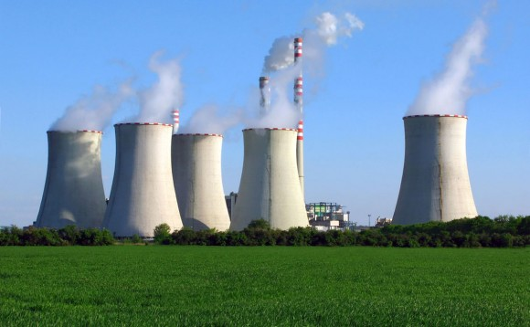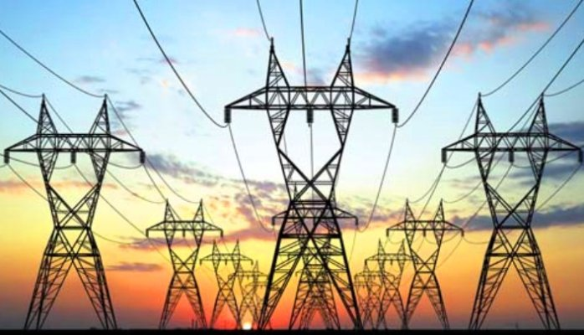

2-1-Country Power Consumption Status

Table 2-1- Country Power Consumption Status till 20 July 2020*

|  |  |  |  |  |
| --- | --- | --- | --- | --- |
| Parameter | Unit | Year 1397  (21 March 2018-21 March 2019) | Till 20 March 2020* | the share of consumption  **(percentage)** |
| Household | **Million kilowatt hours** | 89205 | 28856 | 32/1 |
| Public expenditure | 24713 | 7605 | 8/5 |
| Agriculture | 38574 | 13521 | 15 |
| Industrial | 94470 | 32395 | 36 |
| Other uses (commercial) | 20045 | 5944 | 6/6 |
| lights of Streets | 4894 | 1633 | 1/8 |
| Total Consumption | 271901 | 89954 | 100 |

* This information is updated every two months due to the issuance of subscribers' bills on a two-month basis

2-2- Status of electricity subscribers of the country

Table 2-2- Status of electricity subscribers till 20 July 2020*

|  |  |  |  |  |
| --- | --- | --- | --- | --- |
| Parameter | Unit | Till 20 of March 2019 | Till 20 March 2020* | Grow rate compared to the 20 March 2019  **(percentage)** |
| Household | **Thousand subscribers** | 29392 | 29650 | 0/9 |
| Public expenditure | 1767 | 1787 | 1/1 |
| Agriculture | 464 | 470 | 1/3 |
| Industrial | 254 | 256 | 0/8 |
| Other uses (commercial) | 4766 | 4820 | 1/1 |
| Total subscribers | 36644 | 36983 | 0/9 |

* This information is updated every two months due to the issuance of subscribers' bills on a two-month basis

2-3- Capacity of power plants (nominal and practical), production and consumption requirements

Table 2-3- Capacity of power plants (Nominal & Practical), Production and consumption required till 20 September 2020

|  |  |  |  |  |  |
| --- | --- | --- | --- | --- | --- |
| Growth over the previous month (percent) | Growth rate compared with 20 march 2020 (percent) | **Unit** | share of whole (Percentage) | Value | Installed power plant capacity |
| 0 | 0 | **Megawatt** | 9/18 | 15829 | Thermal Power plant |
| 1/0 | 7/0 | 30/5 | 25498 | Gas Power Plant |
| 6/0 | 9/1 | 31/1 | 25955 | Combined cycle |
| 0 | 0 | 14/5 | 12088 | hydroelectric power plant |
| 0 | 0 | 2/1 | 1020 | Atomic |
| 7/0 | 9 | 2/3 | 1884 | Dispersed production (DG,CHP) |
| 5/0 | 8/1 | 1 | 835 | Renewable Energy power Plant |
| 0 | 0 | 5/0 | 439 | Diesel |
| 0/2 | 1 | 100 | 83548 | Total installed capacity |
| 0 | 2/7 | 52774 | Thermal and Atomic | The practical power of the whole network at peak time, in 2020  (at 14:24 in 20th of May) |
| 0 | 3- | 11647 | Hydroelectric& Renewable Energy power Plant |
| 0 | 2/2 | 64421 | **Total** |
| 0 | 1/3 | 48789 | **Thermal & Atomic** | The simultaneous production of the whole network at peak time 2020  (at 14:24 in 20th of May) |
| 0 | -4/6 | 9098 | Hydroelectric& Renewable Energy power Plant |
| 0 | 1/8 | 57887 | **Total** |
| 0 | 3/424 | 367 | At the peak time in 2020  (at 20:42 in 20th of April) | Receiving energy from abroad |
| 0 | 2/3 | 58254 | Power supplied |
| 0 | 1 | 58245 | The peak time of the day (at 20:42 in 20th of April 2020) | Maximum Consumption requirement corrected in1399(2020) |
| 0 | 3 | 58254 | The peak time of the night (at 20:42 in 20th of April 2020) |
| Growth over the previous month (%) | Growth over the same period in 2019(%) | **Unit** | quantity | Indicator Description | Parameter |
| 32 | 10/2 | **Million kilowatt**  **hours** | 144439 | **Thermal and Atomic** | Generation of electricity from the country since the beginning of 1399(2020) |
| 30/7 | -34/8 | 13060 | Hydroelectric& Renewable Energy power Plant |
| 31/9 | 4/2 | 157499 | **Total** |
| 42/9 | 94/5 | 1270 | Energy Received 1399* (2020) | |
| 34/2 | 5/7 | 3956 | Energy transmitted 1399* (2020) | |
| Reference: Companies managing the power grid of Iran and producing thermal power and SATABA | | | | | |

*Iranian Year**:** from 21 of March every year to 20 March of next year

2-4- Power indicators

Table 2-4- Power indicators in 1399*(2020)

|  |  |  |  |  |  |  |
| --- | --- | --- | --- | --- | --- | --- |
| **value** | **Period of time** | **Unit** | **Index Title** | | | **Row** |
| 58254 | By 20 September 2020 | megawatt | Power consumption peak | | | **1** |
| 1 | By 20 September 2020 | Percentage | Change rate in peak usage this year compared to the same time last year | | | **2** |
| 3/84 | By 20 September 2020 | **Thermal Power Plant** | The share of power generating in the power plants in total power consumption at peak times | | **3** |
| 7/15 | Hydroelectric& Renewable Energy power Plant | **4** |
| 6/38 | (20 March 2019-20 March 2020) | Average efficiency of thermal power plants | | | **5** |
| 28856 | (20 March 2020-20 July 2020) | milion kilowatt hours | Home Subscriber | | electricity consumption | **6** |
| 7605 | Public subscribers | | **7** |
| 13521 | Agricultural subscribers | | **8** |
| 32395 | Industrial customers | | **9** |
| 5944 | Business subscribers | | **10** |
| 1633 | Street lights | | **11** |

*Iranian Year**:** from 21 of March every year to 20 March of next year

Section 3

Renewable Energies

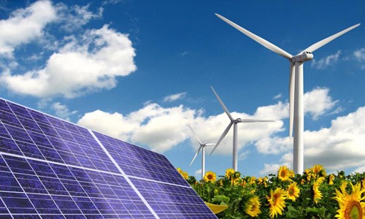

3-1- Report on the renewable and clean (Green) power plants function till 20 September 2020

Table 3-1-The capacity of renewable and clean power plants (governmental and nongovernmental) has been installed till 20 September 2020

|  |  |  |  |  |  |  |  |  |
| --- | --- | --- | --- | --- | --- | --- | --- | --- |
| Percentage of growth compared to previous month | Total | Waste heat power plant (whp) | Biomass | Small hydroelectric power plant | Photovoltaic Power Plant | Wind power plant | Network loss reduction capacity | Type of installed power plants |
| 1/0 | 836 | 13.6 | 10.5 | 105.6 | 404.1 | 302.8 | 65 | Capacity  (MW) |

3-2- Indicators of renewable energy sector

Table 3-2- Renewable Energy Indicators in September 2020

|  |  |  |  |
| --- | --- | --- | --- |
| **Row** | Indicator | **Unit** | **Amount** |
| 1 | Generated electricity from renewable sources | Million kilowatt hours | 175 |
| 2 | Avoid emissions of greenhouse gases* | Thousand tons | 113 |
| 3 | Avoid fossil fuel consumption * | Equivalent to million cubic meters of natural gas | 50 |
| 4 | Avoid water loss * | Million liters | 38 |
| 5 | Renewable Energy Installed Capacity | megawatt | 836 |

* Due to the installation of renewable and clean plants instead of the development of thermal power plants